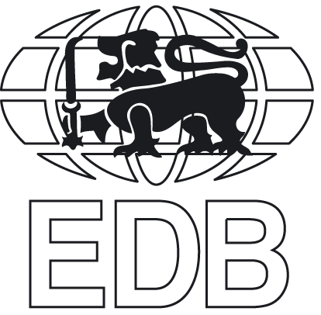Sri Lanka Export Development Board

**SRI LANKA PARTICIPATION AT HKTDC HONG KONG GIFTS & PREMIUM FAIR TO BE HELD FROM 27TH - 30TH APRIL 2025, HONG KONG**

|  |  |  |  |  |  |  |
| --- | --- | --- | --- | --- | --- | --- |
| 01. | Please kindly tick the prgramme that you are interested to particpate   1. Sending samples to display at the Common EDB stall at the HKTDC Hong Kong Gifts & Premium Fair 2. Physically attend at the Trade Mission to visit the HKTDC Hong Kong Gifts & Premium Fair | | | | | |
| 02. | 2.1 Name of the Company ► | | | | | |
| 2.2 Address of the Company ► | | | | | |
| 2.3 Factory/ Workshop Address ► | | | | | |
| 03. | 3.1 Name & Designation of contact person ► | | | | | |
| 3.2 Tel ► Fixed  Mobile | | | 3.3 Fax ► | | |
| 3.4 E-mail ► | | | 3.5 Web ► | | |
| 04. | 4.1 Year of establishment | | | 4.2 Year of commencement of exports | | |
| 05. | EDB Registration Number (if any)► | | | | | |
| 06. | Nature of the business (Pls tick the relevant cage)  □ Manufacturer □ Manufacturer/Exporter  □ Trader □ Other (Please specify)……………………………… | | | | | |
| 07. | Legal Status (Please tick the relevant cage) ▼ **(Please attach a copy)**  □ Proprietorship □ Partnership □ Private Ltd Company  □ Public Quoted Company □ State owned □ Other (Please specify)… | | | | | |
| 08. | Equity ► Local………. % | | Foreign ……….% | |  | |
| 09. | Is your company a part of a group of companies ? Yes □ No □  If yes state ► Name of the Parent Company : | | | | | |
| 10. | Total investment (excluding land buildings) as at 31st March 2024 (Rs. Mn) | | | | | |
| 11. | Total number of employees ►   |  |  |  | | --- | --- | --- | |  | In house | Subcontract | | Skilled |  |  | | Unskilled |  |  | | Designers |  |  | | Managirial Staff |  |  | | | | | | |
| 15. | Current export markets ► | | | | | |
| 16. | Quality standards maintained by the company ► | | | | | |
| 17. | Current capacity and extra capacity available for export ►   |  |  | | --- | --- | | Current Capacity |  | | Extra Capacity |  | | | | | | |
| 18. | Past promotional programmes undertaken by the company in Overseas ► | | | | | |
| 19. | Annual Turnover ►   |  |  |  |  |  |  | | --- | --- | --- | --- | --- | --- | | Year | Local Turnover (US$ Mn) | Export Turnover (US$ Mn) | | | Total Turnover  (Local +Export ) (US$ Mn) | | Local Sales | To the world | To Hong Kong |  | | | 2022 |  |  |  | |  | | 2023 |  |  |  | |  | | 2024 |  |  |  | |  | | | | | | |
|  | If you are wish to apply for programme 01,  Please indicate the products you wish to display at HONG KONG GIFTS & PREMIUM FAIR 2025 ►  ………………………………………………………………………………………………………………………………………………………………………………………………………………………………………….…………………………………………………………………………………………………………………………………………………………………………  If you are wish to apply for programme 02,  Please mention the purpose of attending at the trade mission.  ……………………………………………………………………………………………………..  ……………………………………………………………………………………………………..  …………………………………………………………………………………………………..... | | | | | |
| 20. | Has your company participated at at HKTDC Hong Kong Gifts & Premium Fair before?   |  |  | | --- | --- | | Yes |  | | No |  |   If yes, Please mention the year ……………………………………………………. | | | | | |
| 21. | Your participation of programmes organized by the EDB before ►(Please tick the relevant cage)   |  |  | | --- | --- | | Product Development |  | | Quality Development |  | | Design Development |  | | Sustainability Development |  | | Market Development |  | | | | | | |
| 22. | Do you have any outstanding loan payments to be made to the EDB ► (Please tick the relevant cage)  Yes □ No □  If yes, please give the details ▼ | | | | | |
| *• Please attach audited accounts for past two years (2022/23, 2023/24) and promotional materials (company and product brochures and profiles, literature etc.)* | | | | | | |
| I do hereby certify that the above information furnished by me in this application is true and accurate. | | | | | | |
| **Date** | | **Name & Designation of the person  submitting the above information** | | | | Signature  (company seal) |